THE RESIDENCES PAGE
A Collection by the Water.
A considered collection of Studio, One Bedroom and Two Bedroom residences, thoughtfully positioned along the edge of Hobsonville Point Marina.
Designed to embrace light, outlook and connection to the water, each residence reflects a commitment to timeless design, refined detailing and the art of considered living.
From intimate retreats to more generous waterfront residences, every space has been carefully resolved to create a sense of calm, comfort and enduring quality.

STUDIO RESIDENCES
Considered in Every Detail.
Designed with purpose and precision, the Studio Residences make the most of every element.
Open-plan interiors create a seamless flow between living, kitchen and outdoor spaces, while carefully considered detailing and a refined material palette bring a sense of warmth and sophistication.
Thoughtfully designed for modern waterfront living, each residence offers a beautifully balanced experience where simplicity meets functionality.
View Studio Residences – can we make these images into a carousel?
Remove these- 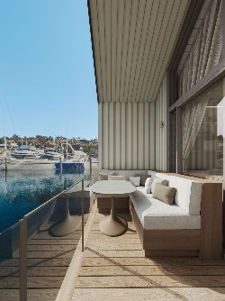 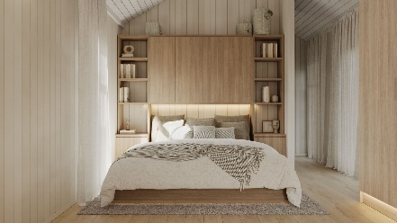 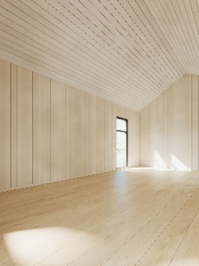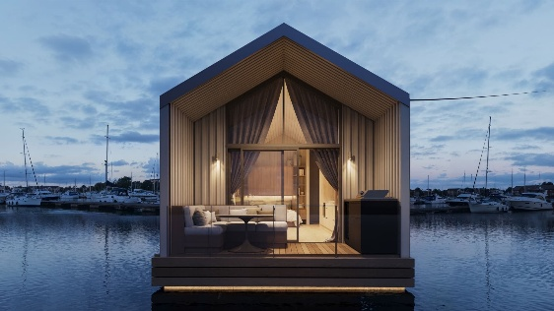 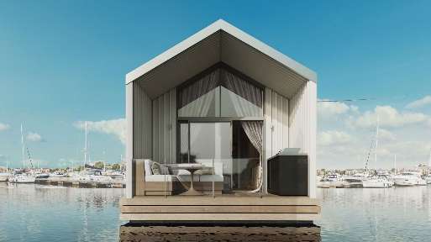 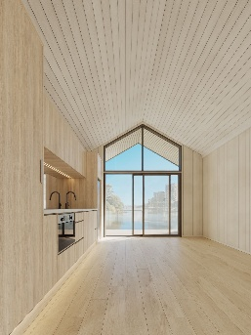

ONE BEDROOM RESIDENCES
Balanced by Design.
Offering a natural balance of openness and retreat, the One Bedroom Residences have been designed around the way people want to reside.
Living spaces extend effortlessly towards private outdoor areas, drawing in natural light and uninterrupted marina outlooks, while carefully positioned bedrooms provide a sense of privacy and calm.
Every element has been considered to create a residence that feels refined, relaxed and connected to the water beyond.

TWO BEDROOM RESIDENCES
Elevated in Scale.
The Two Bedroom Residences offer a heightened sense of space, proportion and connection.
Generous living areas extend naturally towards the marina, creating a seamless relationship between indoors and out, while considered layouts balance openness with privacy.
Designed for those seeking greater flexibility and a deeper connection to the waterfront, these residences offer an elevated expression of life by the water.
View Two Bedroom Residences
Remove all blank renders and 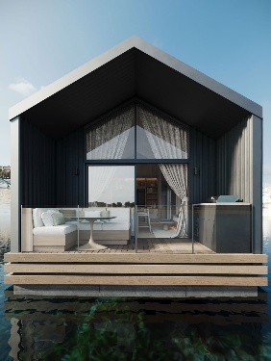 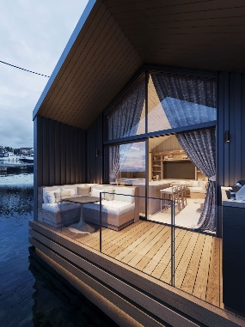

FLOOR PLANS
Considered Layouts.
Every residence has been thoughtfully planned to maximise natural light, functionality and connection to the surrounding environment.
Explore the considered layouts and discover a residence designed around the way you want to live.

CLOSING STATEMENT
Across every residence, thoughtful proportions, refined materials and natural light come together to create spaces that feel timeless, considered and deeply connected to the marina.
A new address on the water, designed to be experienced.
Enquire Now
Our sales team will welcome you to Boathouse Residences and provide further information about this unique waterfront collection.

